Q1.

<!DOCTYPE html>

<html lang="en">

<head>

<meta charset="UTF-8">

<meta name="viewport" content="width=device-width, initial-scale=1.0">

<title>About Me</title>

<style>

body {

font-family: Arial, sans-serif;

margin: 0;

padding: 0;

background-color: #eef79d;

color: #333;

}

header {

background-color: #333;

color: #fff;

padding: 20px;

text-align: center;

}

h1, h2, h3 {

margin: 20px 0;

}

section {

max-width: 800px;

margin: 20px auto;

padding: 0 20px;

}

p {

line-height: 1.6;

margin-bottom: 15px;

}

</style>

</head>

<body>

<header>

<h1>ABOUT ME</h1>

</header>

<section>

<h2>INTRO</h2>

<p>Myself RISHIKA SRIVASTAVA. I'm here to tell you all a bit about me.</p>

<h3>MY OVERALL LIFE</h3>

<p>My life has been a rollercoaster since i hit the age of 16 and is a journey of ups and downs. There are highs but the lows are ay deeper. I'm an emotional freak.</p>

<h3>Passions</h3>

<p>I find myself deeply drawn to various realms such as art, cooking and exploring..</p>

<h3>Aspirations</h3>

<p>Looking ahead, I aspire to basically earn a lot of money and live a happy life.</p>

</section>

<footer>

<h2>Thnxx</h2>

<h2> <p>So that was all about me! See y'all later</p>

</footer>

</body>

</html>

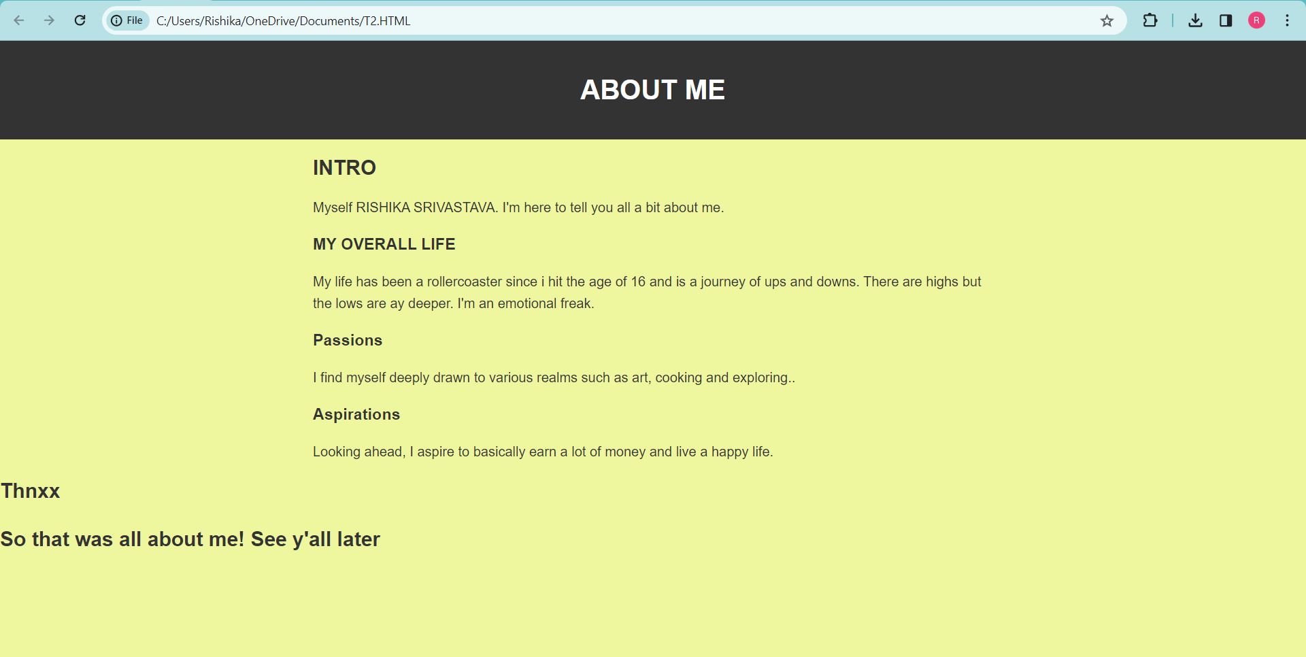

Q2. <!DOCTYPE html>

<html lang="en">

<head>

<meta charset="UTF-8">

<meta name="viewport" content="width=device-width, initial-scale=1.0">

<title>Image Description</title>

<style>

body {

font-family: Arial, sans-serif;

margin: 0;

padding: 0;

background-color: #f4f4f4;

color: #333;

}

header {

background-color: #333;

color: #fff;

padding: 20px;

text-align: center;

}

section {

max-width: 800px;

margin: 20px auto;

padding: 0 20px;

}

img {

max-width: 50%;

height: auto;

display: block;

margin: 0 auto;

}

p {

line-height: 1.6;

margin-bottom: 15px;

}

</style>

</head>

<body>

<header>

<h1>ME</h1>

</header>

<section>

<img src="C:\Users\Rishika\Downloads\RISHIKA.jpg" alt="THIS IS ME">

<p>Rishika is a visionary and optimistic innovator with a highly creative intellect. She believes that “Reality is changing our mind and we change our reality by changing our mind”. She holds an idea to always look upon the brighter side of everything because we’ve all got both light and dark inside us, what matters is the part we choose to act on. Rishika engages herself in ardent and incandescent writings and is a fervent cook. In leisure time she plays badminton. She is a profound and a commendable Orator. Apart from this, the main idea of her life is ‘Friendship is more deep than love’ and she regards friendship above anything in her life..</p>

</section>

</body>

</html>

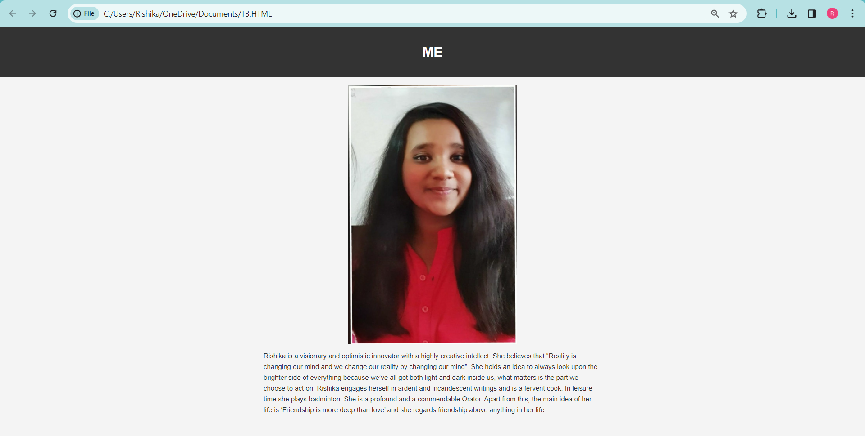

Q3. <!DOCTYPE html>

<html lang="en">

<head>

<meta charset="UTF-8">

<meta name="viewport" content="width=device-width, initial-scale=1.0">

<title>Countries and Spoken Languages</title>

<style>

body {

font-family: Arial, sans-serif;

margin: 0;

padding: 0;

background-color: #f4f4f4;

color: #333;

}

header {

background-color: #333;

color: #fff;

padding: 20px;

text-align: center;

}

section {

max-width: 800px;

margin: 20px auto;

padding: 0 20px;

}

ol {

margin-bottom: 20px;

}

li {

margin-bottom: 10px;

}

</style>

</head>

<body>

<header>

<h1>ITALY CHINA BRAZIL AND THEIR LANGUAGES</h1>

</header>

<section>

<ol type="I">

<li>

<strong>ITALY</strong>

<ol type="A)">

<li>Italian</li>

<li>German</li>

</ol>

</li>

<li>

<strong>CHINA</strong>

<ol type="A)">

<li>Mandarin</li>

<li>Cantonese</li>

</ol>

</li>

<li>

<strong>BRAZIL</strong>

<ol type="A)">

<li>Portuguese</li>

<li>Spanish</li>

</ol>

</li>

</ol>

</section>

</body>

</html>

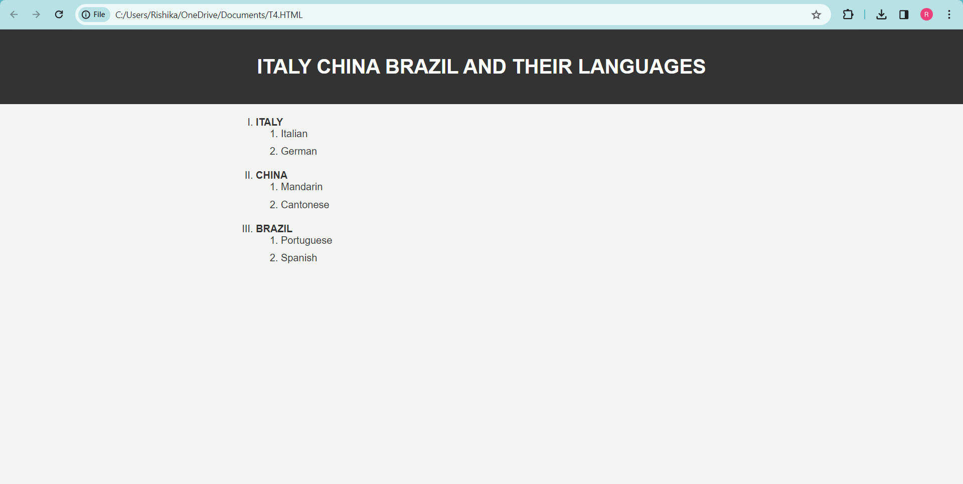

Q4. <!DOCTYPE html>

<html lang="en">

<head>

<meta charset="UTF-8">

<meta name="viewport" content="width=device-width, initial-scale=1.0">

<title>Countries and Capitals</title>

<style>

body {

font-family: Arial, sans-serif;

margin: 0;

padding: 0;

background-color: #f4f4f4;

color: #333;

}

header {

background-color: #333;

color: #fff;

padding: 20px;

text-align: center;

}

table {

width: 80%;

margin: 20px auto;

border-collapse: collapse;

}

th, td {

padding: 10px;

border: 1px solid #ddd;

}

th {

background-color: #e8c5a5;

color: #fff;

}

ul {

margin: 0;

padding-left: 20px;

}

ol {

margin: 0;

padding-left: 20px;

}

</style>

</head>

<body>

<header>

<h1>Countries and Capitals</h1>

</header>

<table>

<tr>

<th>Countries</th>

<th>Capitals</th>

</tr>

<tr>

<td>

<ul>

<li>United States</li>

<li>France</li>

<li>Japan</li>

<li>Italy</li>

<li>China</li>

</ul>

</td>

<td>

<ol>

<li>Washington, D.C.</li>

<li>Paris</li>

<li>Tokyo</li>

<li>Rome</li>

<li>Beijing</li>

</ol>

</td>

</tr>

</table>

</body>

</html>

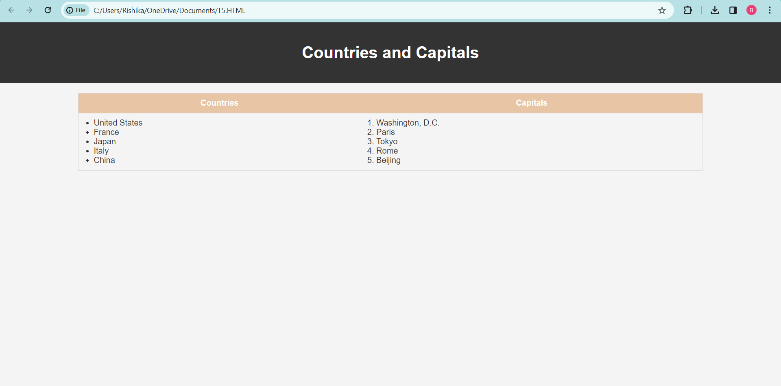

Q5. <!DOCTYPE html>

<html lang="en">

<head>

<meta charset="UTF-8">

<meta name="viewport" content="width=device-width, initial-scale=1.0">

<title>Country Politicians</title>

<style>

table {

border-collapse: collapse;

width: 100%;

}

th, td {

border: 1px solid black;

padding: 8px;

text-align: left;

}

th {

background-color: #f2f2f2;

}

</style>

</head>

<body>

<table>

<thead>

<tr>

<th>Country</th>

<th colspan="2">Politicians</th>

</tr>

</thead>

<tbody>

<!-- Row 1 -->

<tr>

<!-- Column 1: Country -->

<td rowspan="2">Turkmenistan</td>

<!-- Column 2: Politicians -->

<td>President</td>

<td>Gurbanguly Berdimuhamedow</td>

</tr>

<!-- Row 2 -->

<tr>

<td>Vice-President</td>

<td>Raşit Meredow</td>

</tr>

<!-- Row 3 -->

<tr>

<td rowspan="2">Eritrea</td>

<td>President</td>

<td>Isaias Afwerki</td>

</tr>

<!-- Row 4 -->

<tr>

<td>Vice-President</td>

<td>None</td>

</tr>

</tbody>

</table>

</body>

</html>

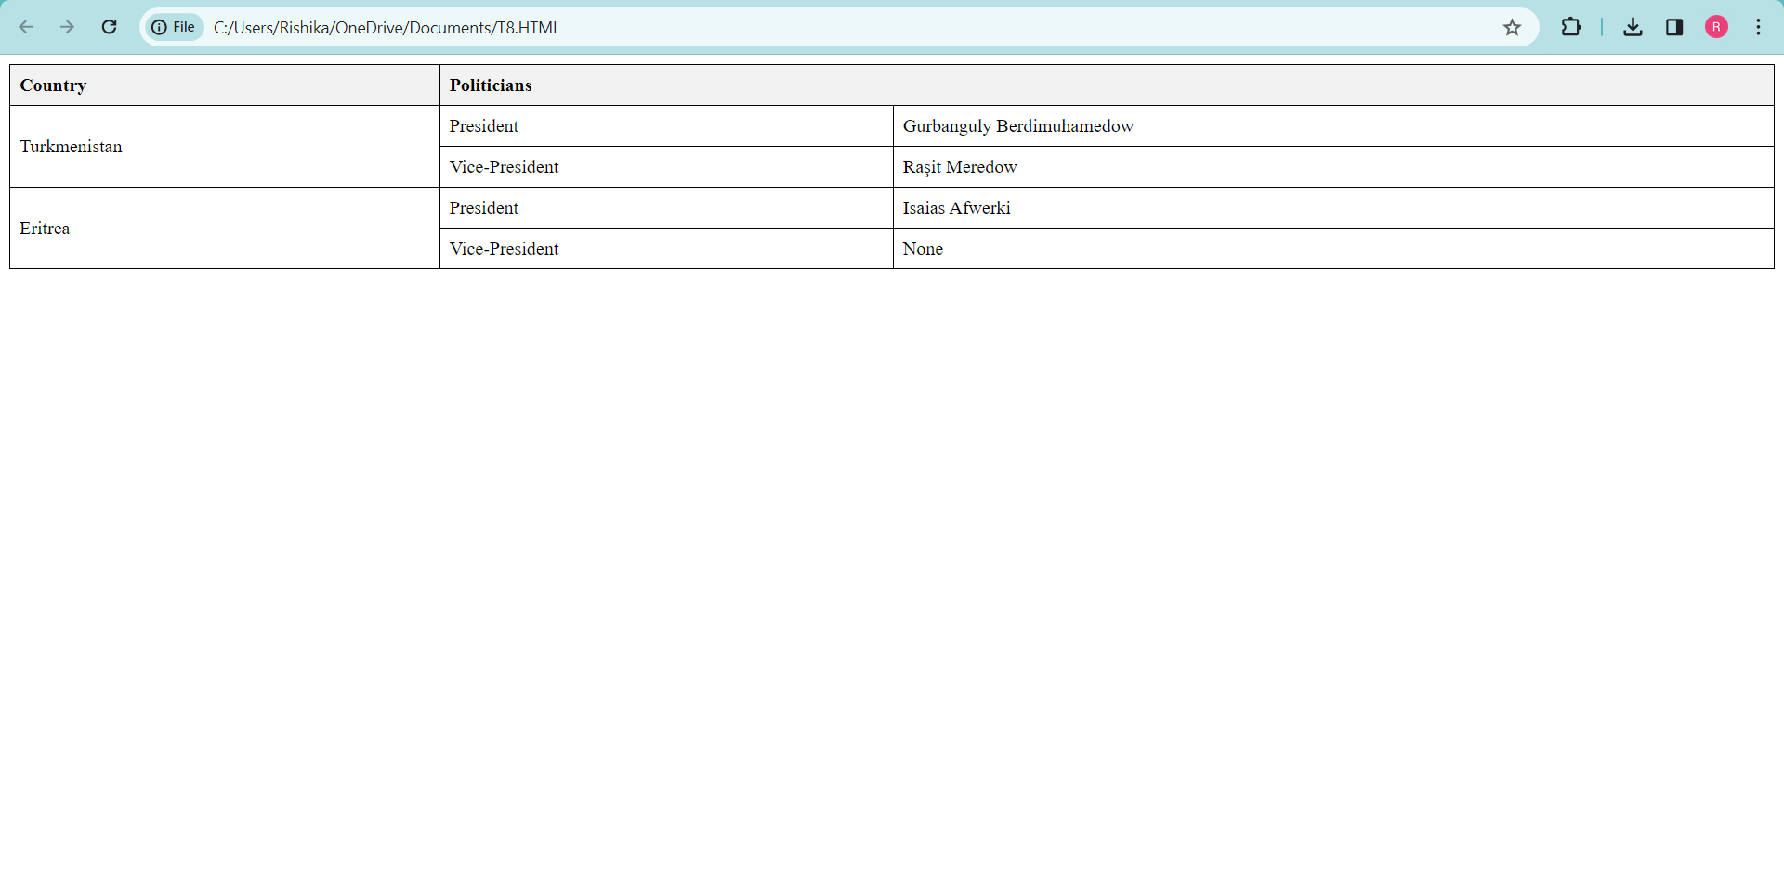

Q6. <!DOCTYPE html>

<html lang="en">

<head>

<meta charset="UTF-8">

<meta name="viewport" content="width=device-width, initial-scale=1.0">

<title>Country Politicians</title>

<style>

table {

border-collapse: collapse;

width: 100%;

}

th, td {

border: 1px solid black;

padding: 8px;

text-align: left;

}

th {

background-color: #f2f2f2;

}

</style>

</head>

<body>

<table>

<thead>

<tr>

<th>Country</th>

<th colspan="2">Politicians</th>

</tr>

</thead>

<tbody>

<!-- Row 1 -->

<tr>

<!-- Column 1: Country -->

<td rowspan="2">Turkmenistan</td>

<!-- Column 2: Politicians -->

<td>President</td>

<td>Gurbanguly Berdimuhamedow</td>

</tr>

<!-- Row 2 -->

<tr>

<td>Vice-President</td>

<td>Raşit Meredow</td>

</tr>

<!-- Row 3 -->

<tr>

<td rowspan="2">Eritrea</td>

<td>President</td>

<td>Isaias Afwerki</td>

</tr>

<!-- Row 4 -->

<tr>

<td>Vice-President</td>

<td>None</td>

</tr>

</tbody>

</table>

</body>

</html>

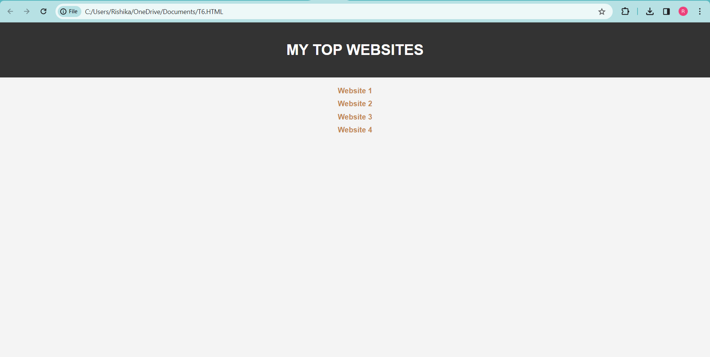

Q7. <!DOCTYPE html>

<html lang="en">

<head>

<meta charset="UTF-8">

<meta name="viewport" content="width=device-width, initial-scale=1.0">

<title>WOMEN EMPOWERMENT</title>

<style>

body {

font-family: Arial, sans-serif;

margin: 0;

padding: 0;

background-color: #f4f4f4;

color: #333;

}

header {

background-color: #333;

color: #fff;

padding: 20px;

text-align: center;

}

section {

max-width: 800px;

margin: 20px auto;

padding: 0 20px;

}

footer {

background-color: #333;

color: #fff;

padding: 20px;

text-align: center;

position: fixed;

bottom: 0;

width: 100%;

}

footer a {

color: #fff;

text-decoration: none;

font-weight: bold;

}

</style>

</head>

<body>

<header>

<h1>WOMEN EMPOWERMENT</h1>

</header>

<section>

<p>This is a sample webpage. Scroll down to see more content.</p>

<p><!DOCTYPE html>

<html lang="en">

<head>

<meta charset="UTF-8">

<meta name="viewport" content="width=device-width, initial-scale=1.0">

<title>WOMEN EMPOWERMENT</title>

<style>

body {

font-family: Arial, sans-serif;

margin: 0;

padding: 0;

background-color: #f4f4f4;

color: #333;

}

header {

background-color: #333;

color: #fff;

padding: 20px;

text-align: center;

}

section {

max-width: 800px;

margin: 20px auto;

padding: 0 20px;

}

footer {

background-color: #333;

color: #fff;

padding: 20px;

text-align: center;

position: fixed;

bottom: 0;

width: 100%;

}

footer a {

color: #fff;

text-decoration: none;

font-weight: bold;

}

</style>

</head>

<body>

</header>

<section>

<p>Women’s empowerment in India

Naturally, when we talk about women’s empowerment in India what we refer that women must need to be aware of their rights like the right to vote, property rights, freedom of movement, their legal rights, and many more, which means, empowering women is making women realize their self-worth, their abilities to determine their own choice and shaping the society where women can enjoy their respect and rights just like other humans. Women’s empowerment is an essential factor that works for the betterment and development of society, community, and country.

When it is to specifying women’s population in the world we get the result of around 50 %. But when we focus on the people of India, it happens to be a disproportionate sex ratio which means the female population is comparatively lower than the male.

Comparatively the western part of the world is very liberal about women’s empowerment but women’s empowerment in India is the least concern of society because of gender biasness. It is believed that the problem with literacy, population, and health issues won’t solve until there’s any solution for the gender biasness so that women can take a free part in building a society and a community where everyone’s rights and demands will be paid attention to.

If we pay more attention to how women’s empowerment in India got momentum throughout the years, from the ancient to the modern period. Over time, Indian society has witnessed many uprises and downfalls when it came to empowering women.

What is women’s empowerment?

Ill-treatment for women has been a ritual for men, for centuries this unjustified treatment is going on, and women are not allowed to have property, they will have no share in their own parents’ properties, and they never enjoyed their rights to vote and there was absolutely no freedom to chose their own way of lifestyle or job and so on.

Now women’s empowerment means exercising their power and their own actions. Which means having control over your own material assets, intellectual resources, and your own ideologies.

Ancient Indian period and women’s empowerment

In ancient Indian culture, women were treated as equal to men, and there was no discrimination on the bases of gender, instead of that women were honored by society, and society at the time considered women as Janani which means mother, even in Hindu scripts women are considered as Devi. They used to enjoy their full basic rights where they were free to receive education, at that time the wives of the rishis could willing to take part in spiritual activities with their husbands, they were also known as the Ardhangini (better half) too. During that period, women got to live equal life just like men used to live. Women in Indian history have gone through two things in their life one is subjection and deliverance. With the passage of time, their positions might have changed but in the Vedic era, they were a complete symbol of protector and caretaker of mortality and ideals.

The accomplishment of Gargi, Maitreyi, Sita, Draupadi, and Alapa turns out to be the most ideal role for women of this era. These women were competitive with men in many fields and also received and enjoyed their rights and equality, there were no restrictions on them, and they possessed great wealth and property. Along with that they even had a very strong say when it came to guiding their offspring.

In the ancient text of the Vedas, the concept of humans is a bedrock for society, in taittiriya Samhita women and men were considered as the two-wheel of a cart. These lessons given by the Vedas to society were good examples of equality between men and women.

Women’s empowerment in India in the medieval period

The integrity among the genders had room in the early Vedic period but somehow in the later Vedic period there was a decline in the integrity and equality among them, especially the position of the women which was equal in the early Vedic period, later had a downward trend in later Vedic period. It is believed that foreign conquest is the main reason for the decline of women’s status in that era. There was an erosion in the Rig-Vedic ideals of fairness and harmony, which deprives women to enjoy their right to study the Vedas, recite Vedic mantras, and practice Vedic rituals. Women were forced to get married and or involve in domestic life and have an indisposable devotion to their husbands. At that time parents were ashamed of the born of a girl child..</p>

<!-- Add more content if needed -->

</section>

<footer>

<a href="#" onclick="scrollToTop(); return false;">Back to Top</a>

</footer>

<script>

function scrollToTop() {

window.scrollTo({

top: 0,

behavior: 'smooth'

});

}

</script>

</body>

</html>

.</p>

<!-- Add more content if needed -->

</section>

<footer>

<a href="#" onclick="scrollToTop(); return false;">Back to Top</a>

</footer>

<script>

function scrollToTop() {

window.scrollTo({

top: 0,

behavior: 'smooth'

});

}

</script>

</body>

</html>

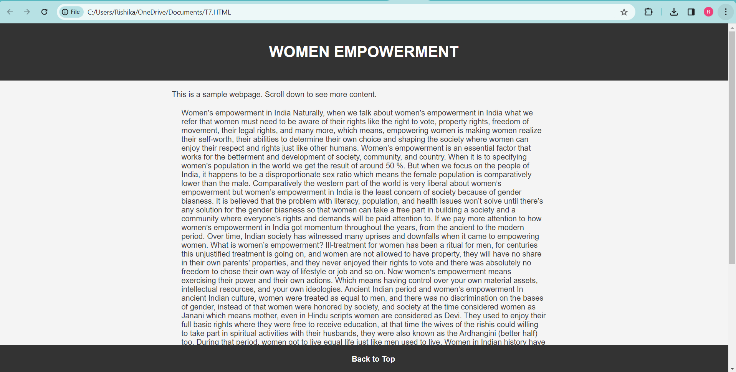

Q8. <!DOCTYPE html>

<html lang="en">

<head>

<meta charset="UTF-8">

<meta name="viewport" content="width=device-width, initial-scale=1.0">

<titleWOMEN EMPOWERMENT</title>

<style>

body {

font-family: Arial, sans-serif;

margin: 0;

padding: 0;

background-color: #f4f4f4;

color: #333;

text-align: center;

}

header {

background-color: #333;

color: #fff;

padding: 20px;

}

section {

max-width: 800px;

margin: 20px auto;

padding: 0 20px;

}

footer {

background-color: #333;

color: #fff;

padding: 20px;

text-align: center;

}

a {

color: #007bff;

text-decoration: none;

font-weight: bold;

}

a:hover {

text-decoration: underline;

}

</style>

</head>

<body>

<header>

<h1>WOMEN EMPOWERMENT</h1>

<a href="#bottom">Jump to Bottom</a>

</header>

<section>

<p>This is a sample webpage. Scroll down to see more content.</p>

<p>Naturally, when we talk about women’s empowerment in India what we refer that women must need to be aware of their rights like the right to vote, property rights, freedom of movement, their legal rights, and many more, which means, empowering women is making women realize their self-worth, their abilities to determine their own choice and shaping the society where women can enjoy their respect and rights just like other humans. Women’s empowerment is an essential factor that works for the betterment and development of society, community, and country.

When it is to specifying women’s population in the world we get the result of around 50 %. But when we focus on the people of India, it happens to be a disproportionate sex ratio which means the female population is comparatively lower than the male.

Comparatively the western part of the world is very liberal about women’s empowerment but women’s empowerment in India is the least concern of society because of gender biasness. It is believed that the problem with literacy, population, and health issues won’t solve until there’s any solution for the gender biasness so that women can take a free part in building a society and a community where everyone’s rights and demands will be paid attention to.

If we pay more attention to how women’s empowerment in India got momentum throughout the years, from the ancient to the modern period. Over time, Indian society has witnessed many uprises and downfalls when it came to empowering women.

What is women’s empowerment?

Ill-treatment for women has been a ritual for men, for centuries this unjustified treatment is going on, and women are not allowed to have property, they will have no share in their own parents’ properties, and they never enjoyed their rights to vote and there was absolutely no freedom to chose their own way of lifestyle or job and so on.

Now women’s empowerment means exercising their power and their own actions. Which means having control over your own material assets, intellectual resources, and your own ideologies.

Ancient Indian period and women’s empowerment

In ancient Indian culture, women were treated as equal to men, and there was no discrimination on the bases of gender, instead of that women were honored by society, and society at the time considered women as Janani which means mother, even in Hindu scripts women are considered as Devi. They used to enjoy their full basic rights where they were free to receive education, at that time the wives of the rishis could willing to take part in spiritual activities with their husbands, they were also known as the Ardhangini (better half) too. During that period, women got to live equal life just like men used to live. Women in Indian history have gone through two things in their life one is subjection and deliverance. With the passage of time, their positions might have changed but in the Vedic era, they were a complete symbol of protector and caretaker of mortality and ideals.

The accomplishment of Gargi, Maitreyi, Sita, Draupadi, and Alapa turns out to be the most ideal role for women of this era. These women were competitive with men in many fields and also received and enjoyed their rights and equality, there were no restrictions on them, and they possessed great wealth and property. Along with that they even had a very strong say when it came to guiding their offspring.

In the ancient text of the Vedas, the concept of humans is a bedrock for society, in taittiriya Samhita women and men were considered as the two-wheel of a cart. These lessons given by the Vedas to society were good examples of equality between men and women.

Women’s empowerment in India in the medieval period

The integrity among the genders had room in the early Vedic period but somehow in the later Vedic period there was a decline in the integrity and equality among them, especially the position of the women which was equal in the early Vedic period, later had a downward trend in later Vedic period. It is believed that foreign conquest is the main reason for the decline of women’s status in that era. There was an erosion in the Rig-Vedic ideals of fairness and harmony, which deprives women to enjoy their right to study the Vedas, recite Vedic mantras, and practice Vedic rituals. Women were forced to get married and or involve in domestic life and have an indisposable devotion to their husbands. At that time parents were ashamed of the born of a girl child.</p>

<!-- Add more content if needed -->

</section>

<footer id="bottom">

<a href="#top">Back to Top</a>

</footer>

<a id="top"></a>

</body>

</html>

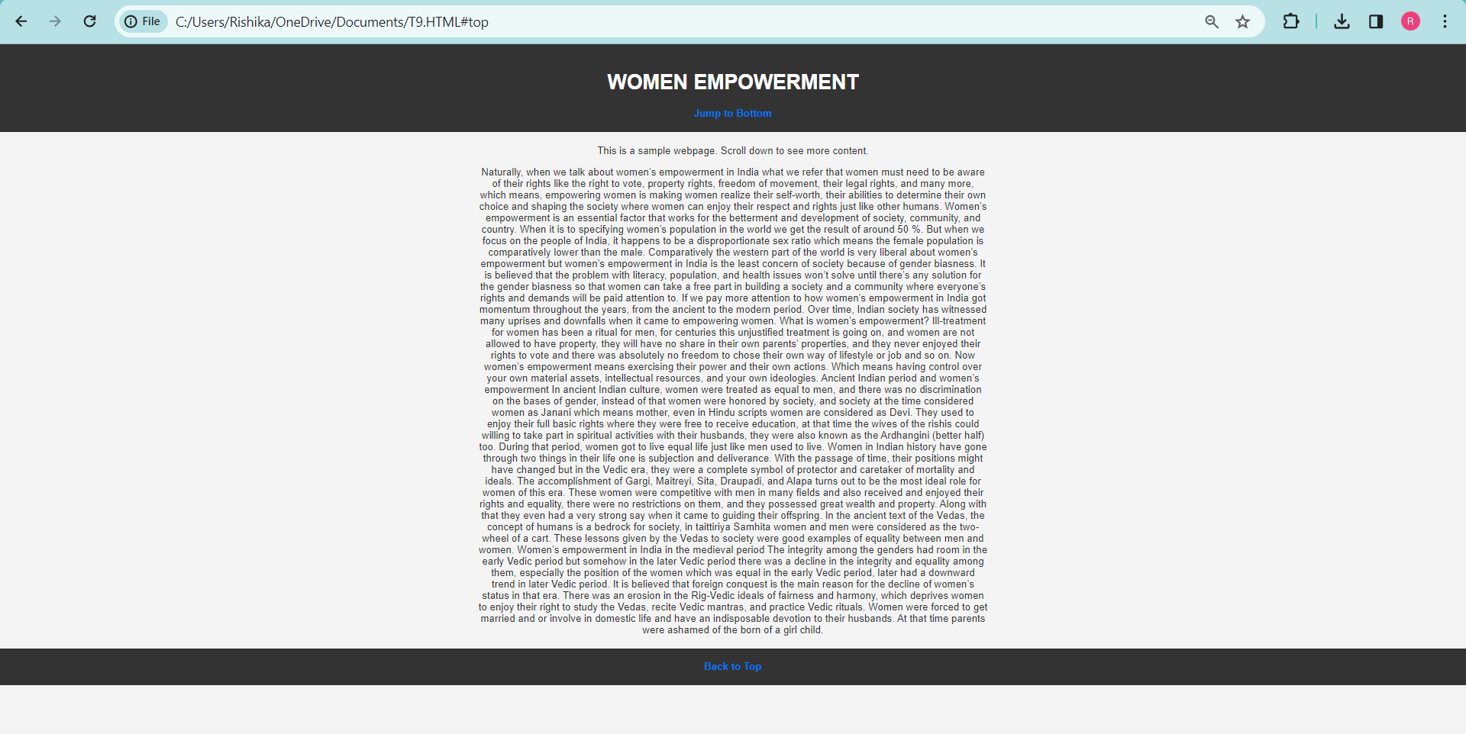

Q9. <!DOCTYPE html>

<html lang="en">

<head>

<meta charset="UTF-8">

<meta name="viewport" content="width=device-width, initial-scale=1.0">

<title>MY PHOTOGRAPH WITH BORDER</title>

<style>

img {

border: 2px solid black;

width: 200px;

height: 200px;

}

</style>

</head>

<body>

<header>

<h1>MY PHOTOGRAPH WITH BORDER</h1>

</header>

<section>

<img src="C:\Users\Rishika\Downloads\RISHIKA.jpg" alt="RISHIKA">

</section>

</body>

</html>

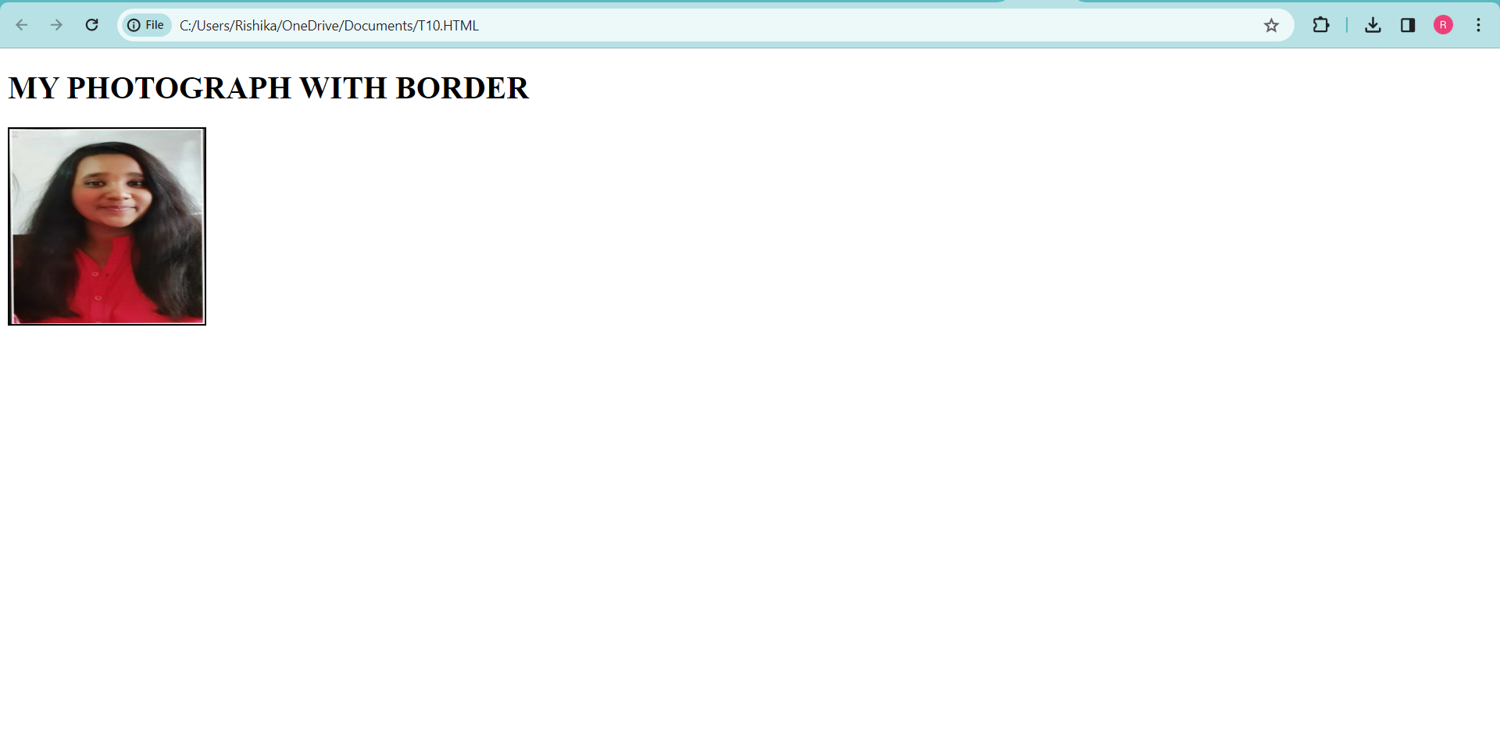

Q10. <!DOCTYPE html>

<html lang="en">

<head>

<meta charset="UTF-8">

<meta name="viewport" content="width=device-width, initial-scale=1.0">

<title>RISHIKA'S GALLERY</title>

</head>

<body>

<header>

<h1>RISHIKA'S GALLERY</h1>

</header>

<section>

<figure>

<img src="C:\Users\Rishika\Downloads\P1.jpeg" alt="FLOWWER" width="300" height="200">

</figure>

<br><br>

<figure>

<img src="C:\Users\Rishika\Downloads\P2.jpeg" alt="FLOWER" width="300" height="200">

</figure>

<br><br>

<figure>

<img src="C:\Users\Rishika\Downloads\P3.jpeg" alt="FLOWER" width="300" height="200">

</figure>

<br><br>

<figure>

<img src="C:\Users\Rishika\Downloads\P4.jpeg" alt="FLOWER" width="300" height="200">

</figure>

<br><br>

<figure>

<img src="C:\Users\Rishika\Downloads\P5.jpeg" alt="FLOWER" width="300" height="200">

</figure>

<br><br>

</section>

</body>

</html>

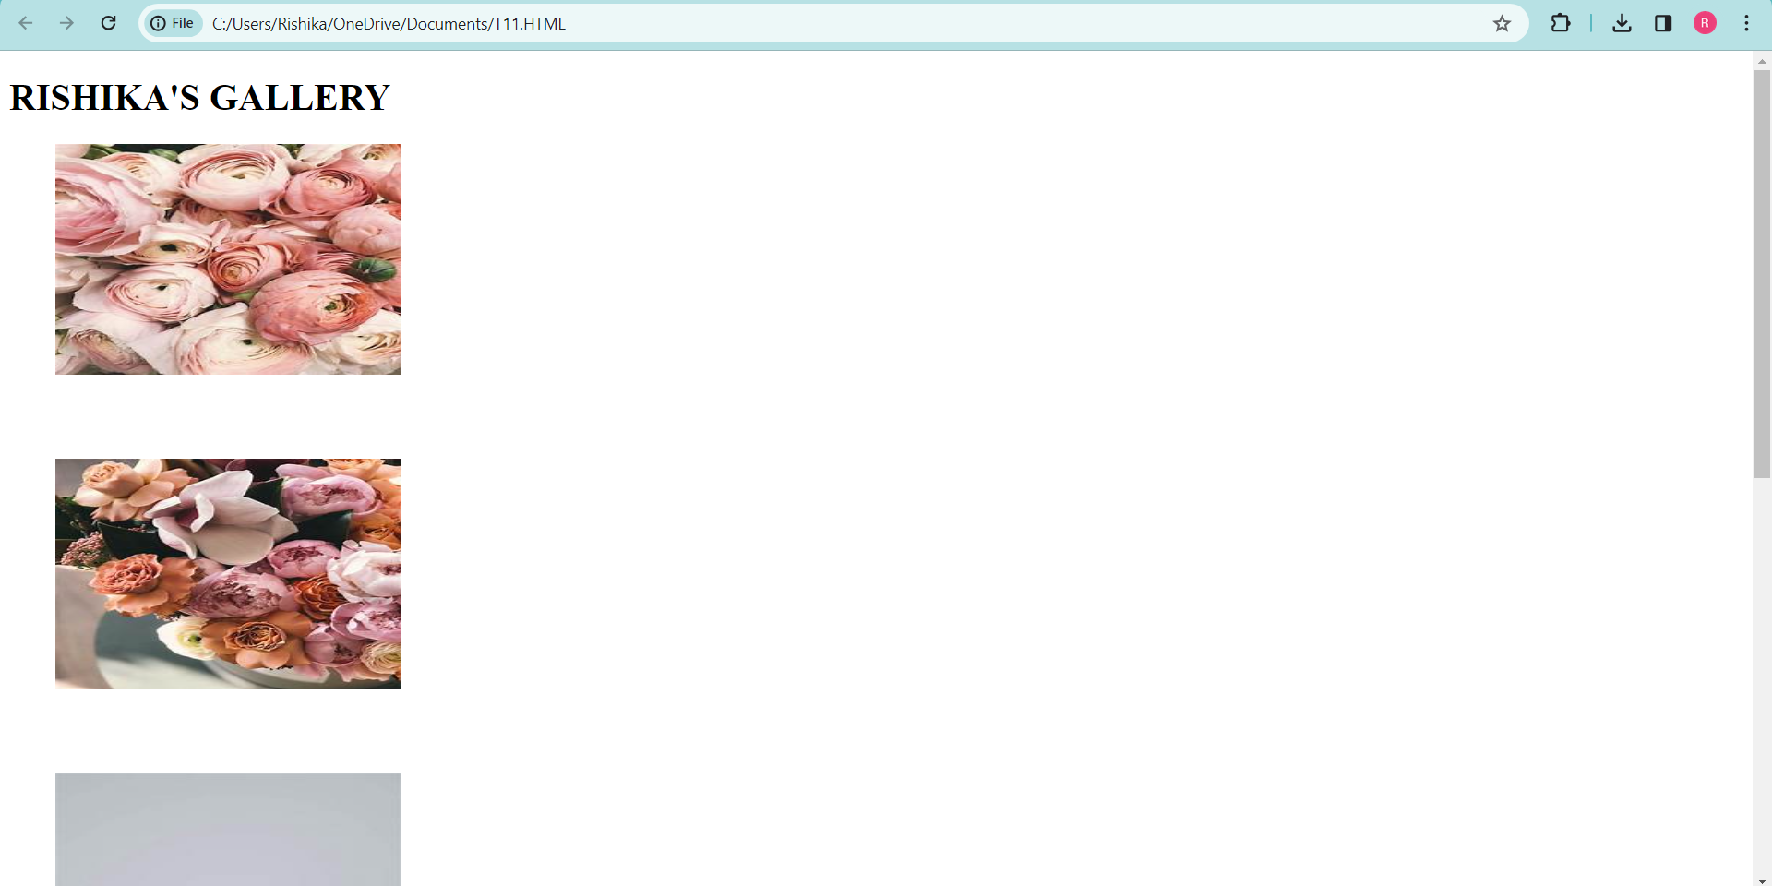

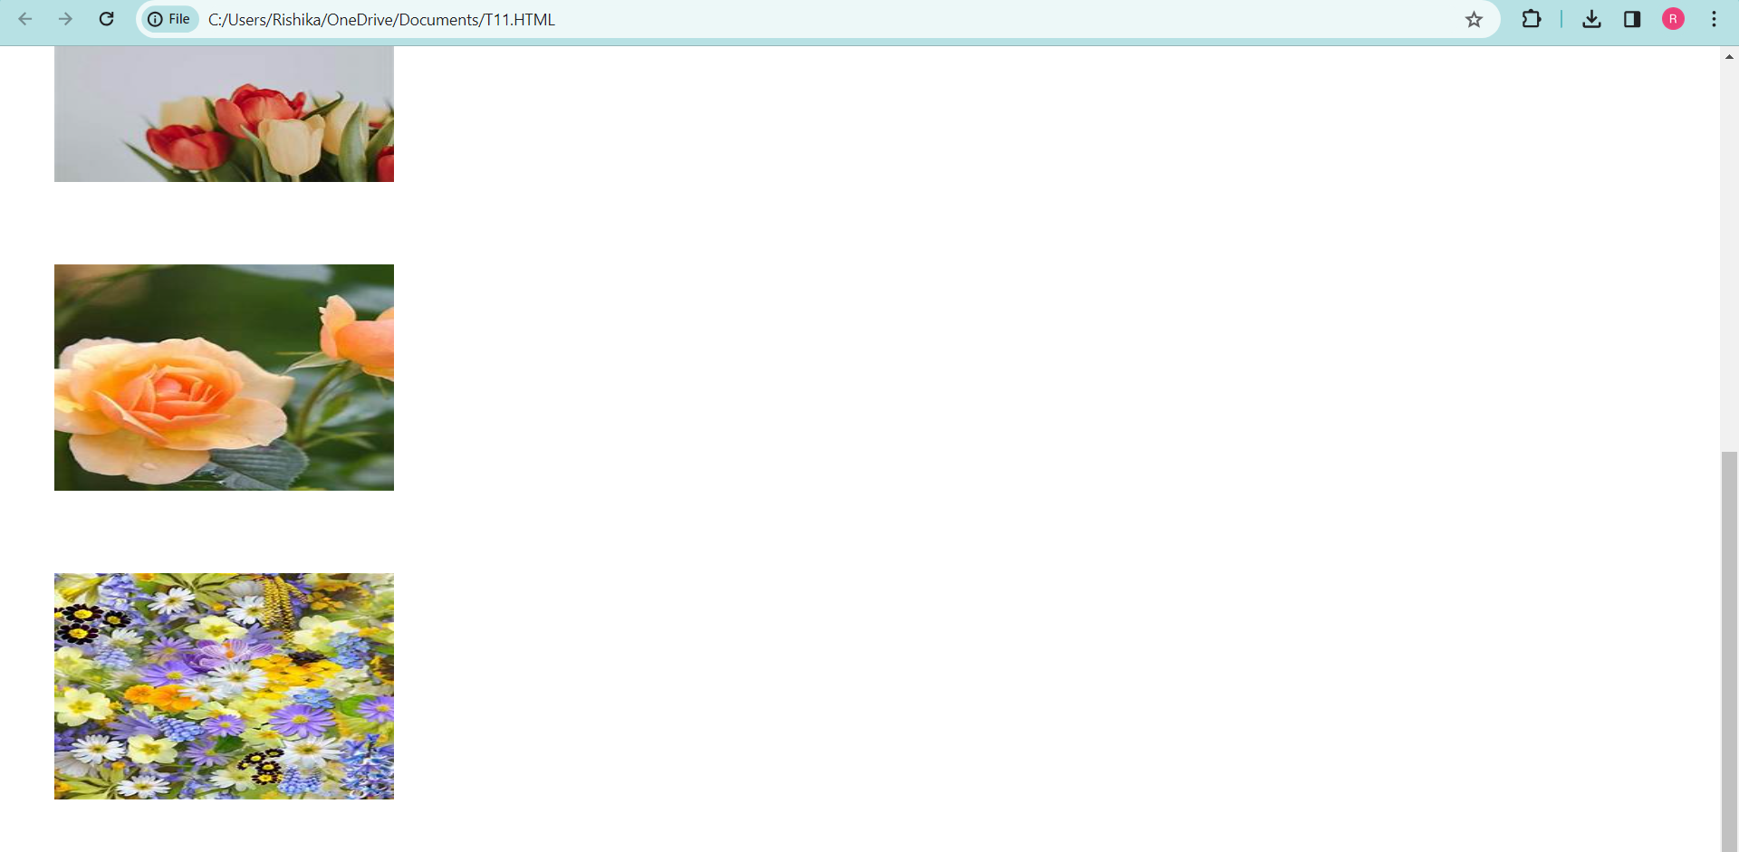

Q11.

<!DOCTYPE html>

<html lang="en">

<head>

<meta charset="UTF-8">

<meta name="viewport" content="width=device-width, initial-scale=1.0">

<title>Clickable Image made by RISHIKA</title>

</head>

<body>

<header>

<h1>Clickable Image made by RISHIKA</h1>

</header>

<section>

<a href="https://www.unsplash.com" target="_blank">

<img src="C:\Users\Rishika\Downloads\P3.jpeg" alt="FLOWER" width="300" height="200">

</a>

</section>

</body>

</html>

